Bristol Elementary School
Parent School Support Committee
Meeting #2 24, November 2015

Present: Colleen Wiley, Joanne Curtis, Tara Orchard, Anne McGilligan, Krystn Davis, Colleen MacDonald Briggs

Absent with regrets: Tanya Harvey and Amanda Gibbons

The Meeting was called to order at 7:00pm by chair Anne McGilligan. The first piece of business was items from the community – specifically, school pictures. Bristol Elementary’s school pictures are provided by Greatakes Photography, operated by Pam Everett. Anne shared that she has had several parents complain about the pictures (price, quality, mix ups). The groups discussion focused on these issues and then concluded that the price was less expensive than other providers in the area and that the environmental poses which were provided and the photographer’s flexibility made up for the errors which did occur. The group also wanted to continue to support a local business. Colleen agreed to ask Ms. Everett to notify parents regarding late photos and to request that digital copies be made available for purchase.

Anne then proceeded with the agenda as prepared. The province’s Ten Year Education Plan was discussed. Members who attended the meeting on October 22nd found that there was a lot of information there and data, but no answers to specific questions. Members also felt that the questions were very broad and difficult to answer. The group did provide feedback to Colleen – see attachment.

Colleen then shared with the committee the activities taking place at Bristol Elementary during the month of November around diversity and anti-bullying. The school began the month celebrating Student of the Month on November 2nd and discussing the difference between conflict and bullying. Colleen also shared that this information is on the school website for parents. The school took literacy buddy time to write anti bullying messages that children will share during morning announcements and concluded the month with a multiage activity that group students according to their dominant intelligence to complete anti bullying activities.

Anne proceeded with the next item – Report Card Feedback. Parents felt the report cared was more informative that the previous progress reports and appreciated the amount of information and time teachers took to complete the reports. The comment sheet at the back was new and they wondered if it would continue to be used. Colleen shared that it was to be used for the entire school year.
Colleen then shared the school global budget which has a balance of $11 052.34 to be spent by March 31st. The cashnet account has a balance of $10 303.65 which includes the $5000 grant from the McCain Foundation to support subsidized lunches at Bristol Elementary. Colleen also shared that the recent fundraiser selling baked potatoes raised $550 for the school. This money will be used to supplement the purchase of literacy materials, phys.ed equipment and a playground bench.

Anne then asked Collen to report on the provincial assessment results. Results are for reading at the grade 2 level. See below:
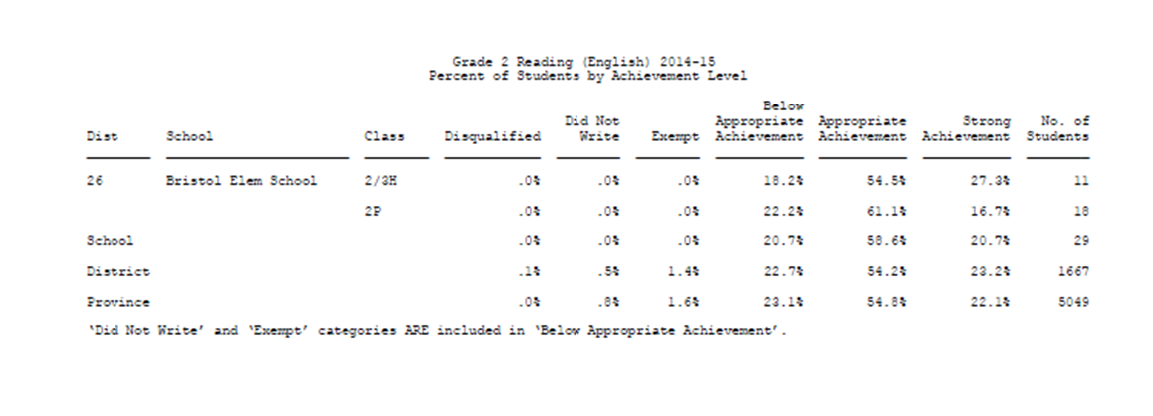
Colleen shared that the school achieved 79.3% of the students reading at acceptable or higher. This is down compared to the last two years. Colleen shared that it was a large group of 29 students and while most (over 90%) had the ability and skill to be successful, not all students perform well on assessments. This could be due to perseverance, independence and or interest. Students who were not successful will continue to be monitored and given support when necessary. Members inquired if individual results were available. Colleen shared that they were upon request.

The final piece of business for the meeting involved Colleen sharing the SIP and PLEP with the committee. Colleen highlighted the 3 main goals of the SIP (continued improvement as, of and for assessment, enhanced positive learning and working environment, and continued building of leadership capacity). Colleen shared that the school was continuing to develop professionally with an emphasis on understanding and teaching to the diverse needs and learning styles of our students. This will be done through teaching students about their learning strengths and challenges, the development of more lesson planning to support this and further professional reading. The school was going to also continue with helping students set goals in their writing by identifying needs through the use of appropriate writing exemplars or models that are displayed in the classrooms and used during conferences.

Colleen also shared the PLEP’s two main goals to increase student engagement in the school and reduce bullying incidents. Bristol Elementary will continue to offer many activities at recesses and afterschool to support student interests.

After the sharing of the SIP and PLEP there was no further business and the meeting adjourned at 8:35pm.

Next meeting Tuesday January 19th at 7pm.

